**CPUB S/N 002 incoming inspection**

* Slightly crooked parts flagged as process indicators. Side overhang is >0 but <25%.

R52, R62, R65, R145

* Slight oversolder on C112, R201, R98, R43, R47 – appears hand-soldered touch-up
* Connections not shiny – appears to be flux residue.
* Capacitor polarities good?
* IC orientations good
* Diode polarities good?
* Drill alignment good

Clean board of flux residue __DKH____

11/13/2020 D. Hamara

1. Install wedgelocks with 100° screws
   1. 100° screws do not self-center very well
2. Test mechanical fit in FE box
   1. Backplane connector aligns nicely
3. Install front panel connectors _______DKH___________
   1. Pre-install J7 with NAS1101-04-6 screws, NO washer on top, NAS620C4L washer, and commercial small nut. Tighten finger tight, do not solder
   2. Press J10 – J13 into PWB, do not solder
   3. Place front panel on top, press against blank end panel. Secure with 4 x 6-32 x 5/16 cap screws
      1. Loosen wedgelocks slightly
      2. place 2 x 4-40 x 5/16 cap screws with NAS620C4L washers into each of the USB connectors finger tight
      3. Install 2 jackposts into J7, finger tight
      4. Press USB connectors into board so they are aligned with the holes in the front panel
      5. Tighten wedgelocks
      6. Tighten screws in USB connectors, making sure the faces of the connectors stay aligned with the faceplate holes
      7. Tighten jackposts on J7
   4. Solder all 5 connectors
   5. Clean and inspect.
   6. Remove front panel (DPA unit ONLY) _______DKH_____________
4. Install J9 ____DKH____________
5. Install J15 _____DKH___________
6. Install J1 ______DKH_____________
7. Set Board ID (DPA CPU = 0x2A, Jump bits ID6, ID4, ID2) ____DKH___________
8. Install CPU to CN1, CN2 ________DKH______________
9. Smoke Test
   1. Resistance tests on J4 (Fluke 8060A, 20K range)

|  |  |  |
| --- | --- | --- |
| + | - | Reading |
| +5V | GND | OPEN |
| +3.3 | GND | 358Ω |
| +9 | GND | OPEN |
| GND | -9 | OPEN |
| +28 | GND | OPEN |

* + 1. Connect current limited power to +5, +9, -9 on J4
  1. Connect terminal to J7,115.2Kbaud, 8 bits, 1 stop
  2. Turn on power
     1. +5 @ 250mA
     2. ±9 @ 0
     3. Red LED comes on, a bunch of boot stuff on screen, then green LED
  3. PASS _______DKH_____________

P

# Photos of completed assembly work

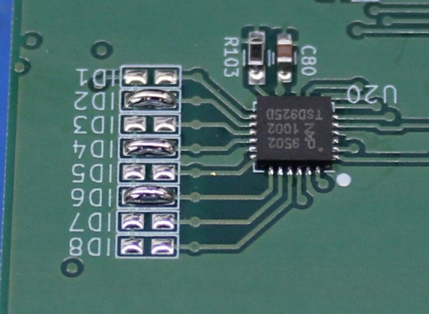 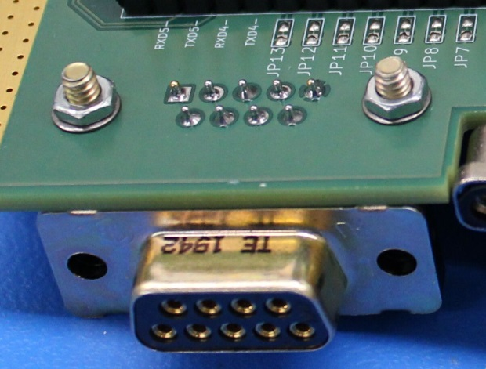

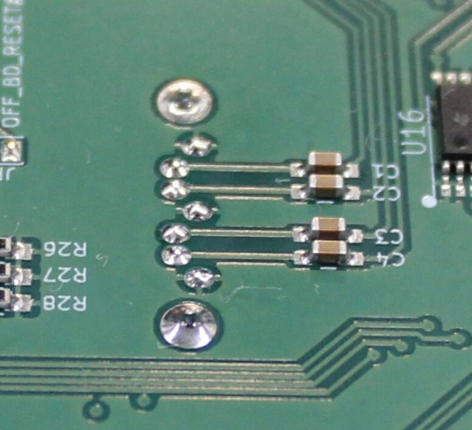 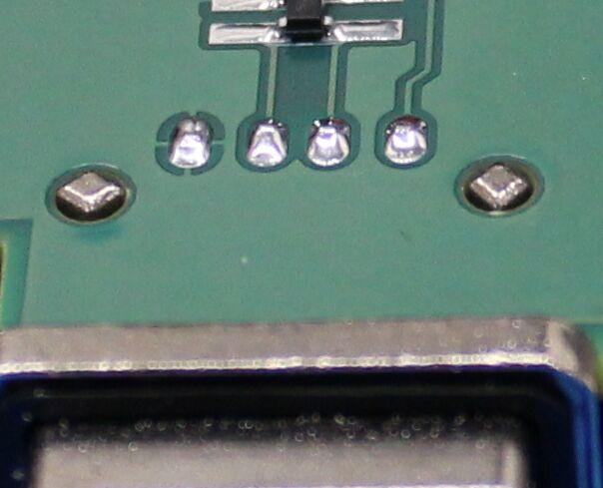

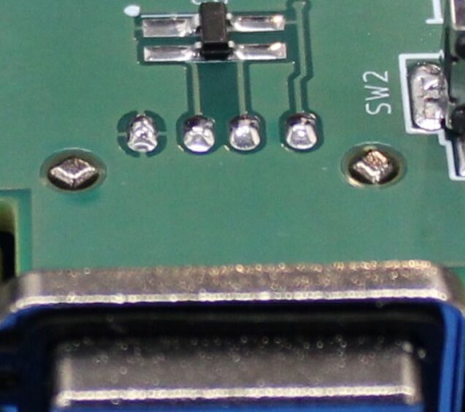 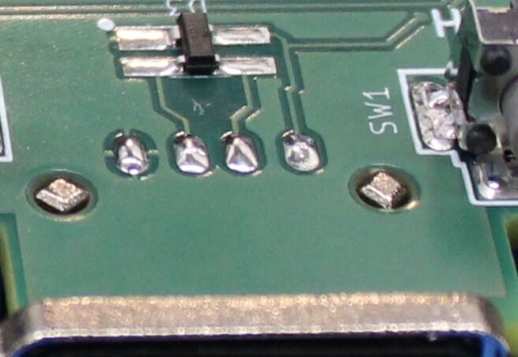

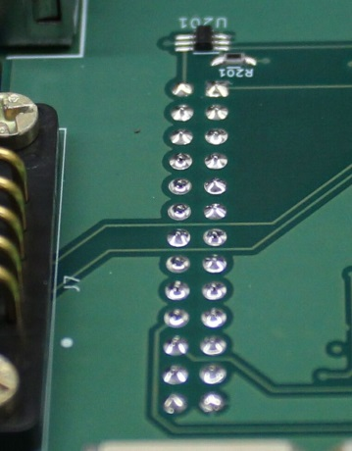

# Mate/Demate Log

|  |  |  |  |  |
| --- | --- | --- | --- | --- |
| Connector | M / D | Date | Initial | Comments |
| J2 | M | 11/13/2020 | DKH | FE Box fit check |
| J2 | D | 11/14/2020 | DKH | Demate for connector soldering |
| J2 | M | 11/14/2020 | DKH | Final fit check |
| J2 | D | 11/14/2020 | DKH | Remove for smoke test |
| CN1, CN2 | M | 11/16/2020 | DKH | Install random CPU for smoke test |
| J9 | M, D | 11/16/2020 | DKH | Test Ethernet interface |
| CN1, CN2 | D, M | 11/17/2020 | DKH | Replace test CPU with flight quad core |
|  |  |  |  |  |
|  |  |  |  |  |
|  |  |  |  |  |
|  |  |  |  |  |
|  |  |  |  |  |
|  |  |  |  |  |
|  |  |  |  |  |
|  |  |  |  |  |
|  |  |  |  |  |
|  |  |  |  |  |
|  |  |  |  |  |
|  |  |  |  |  |
|  |  |  |  |  |
|  |  |  |  |  |
|  |  |  |  |  |
|  |  |  |  |  |
|  |  |  |  |  |
|  |  |  |  |  |
|  |  |  |  |  |
|  |  |  |  |  |
|  |  |  |  |  |
|  |  |  |  |  |
|  |  |  |  |  |
|  |  |  |  |  |
|  |  |  |  |  |
|  |  |  |  |  |
|  |  |  |  |  |
|  |  |  |  |  |
|  |  |  |  |  |
|  |  |  |  |  |
|  |  |  |  |  |
|  |  |  |  |  |
|  |  |  |  |  |
|  |  |  |  |  |
|  |  |  |  |  |